The activities of database design transform the requirements for data storage developed during database analysis into specifications to guide database implementation. There are two forms of specifications:
- Logical specifications, which map the conceptual requirements into the data model associated with a specific database management system.
- Physical specifications, which indicate all the parameters for data storage that are then used as input for database implementation. During this phase, a database is actually defined using a data definition language.
In Chapter 4 (“Logical Database Design and the Relational Model”), we describe logical database design, with special emphasis on the relational data model. Logical database design is the process of transforming the conceptual data model (described in Chapters 2 and 3) into a logical data model. Most database management systems in use today are based on the relational data model, so this data model is the basis for our discussion of logical database design.
In Chapter 4, we first define the important terms and concepts for this model, including relation, primary key and surrogate primary key, foreign key, anomaly, normal form, normalization, functional dependency, partial functional dependency, and transitive dependency. We next describe and illustrate the process of transforming an E-R model to the relational model. Many modeling tools support this transformation; however, it is important that you understand the underlying principles and procedures. We then describe and illustrate in detail the important concepts of normalization (the process of designing well-structured relations). Appendix B, on the book’s Web site, includes further discussion of normalization. Finally, we describe how to merge relations from separate logical design activities (e.g., different groups within a large project team) while avoiding common pitfalls that may occur in this process. We end this discussion with a presentation of enterprise keys, which make relational keys distinct across relations.

Chapter 4 Logical Database Design and the Relational Model

Learning Objectives
After studying this chapter, you should be able to:
- Concisely define each of the following key terms: relation, primary key, composite key, foreign key, null, entity integrity rule, referential integrity constraint, well-structured relation, anomaly, surrogate primary key, recursive foreign key, normalization, normal form, functional dependency, determinant, candidate key, first normal form, second normal form, partial functional dependency, third normal form, transitive dependency, synonyms, alias, homonym, and enterprise key.
- List five properties of relations.
- State two essential properties of a candidate key.
- Give a concise definition of each of the following: first normal form, second normal form, and third normal form.
- Briefly describe four problems that may arise when merging relations.
- Transform an E-R (or EER) diagram into a logically equivalent set of relations.
- Create relational tables that incorporate entity integrity and referential integrity constraints.
- Use normalization to decompose a relation with anomalies into well-structured relations.
Visit www.pearsonhighered.com/hoffer to view the accompanying video for this chapter.

Introduction
In this chapter, we describe logical database design, with special emphasis on the relational data model. Logical database design is the process of transforming the conceptual data model (described in Chapters 2 and 3) into a logical data model—one that is consistent and compatible with a specific type of database technology. An experienced database designer often will do logical database design in parallel with conceptual data modeling if he or she knows the type of database technology that will be used. It is, however, important to treat these as separate steps so that you concentrate on each important part of database development. Conceptual data modeling is about understanding the organization—getting the requirements right. Logical database design is about creating stable database structures—correctly expressing the requirements in a technical language. Both are important steps that must be performed carefully.
Although there are other logical data models, we have two reasons for emphasizing the relational data model in this chapter. First, the relational data model is by far the one most commonly used in contemporary database applications. Second, some of the principles of logical database design for the relational model apply to the other logical models as well.
We have introduced the relational data model informally through simple examples in earlier chapters. It is important, however, to note that the relational data model is a form of logical data model, and as such it is different from the conceptual data models. Thus, an E-R data model is not a relational data model, and an E-R model may not obey the rules for a well-structured relational data model, called normalization, which we explain in this chapter. That is okay, because the E-R model was developed for other purposes—understanding data requirements and business rules about the data—not structuring the data for sound database processing, which is the goal of logical database design.
In this chapter, we first define the important terms and concepts for the relational data model. (We often use the abbreviated term relational model when referring to the relational data model.) We next describe and illustrate the process of transforming an EER model into the relational model. Many CASE tools support this transformation today at the technical level. It is, however, important that you understand the underlying principles and procedures. We then describe the concepts of normalization in detail. Normalization, which is the process of designing well-structured relations, is an important component of logical design for the relational model. Finally, we describe how to merge relations while avoiding common pitfalls that may occur in this process.
The objective of logical database design is to translate the conceptual design (which represents an organization’s requirements for data) into a logical database design that can be implemented via a chosen database management system. The resulting databases must meet user needs for data sharing, flexibility, and ease of access. The concepts presented in this chapter are essential to your understanding of the database development process.
The Relational Data Model
The relational data model was first introduced in 1970 by E. F. Codd, then of IBM (Codd, 1970). Two early research projects were launched to prove the feasibility of the relational model and to develop prototype systems. The first of these, at IBM’s San Jose Research Laboratory, led to the development of System R (a prototype relational DBMS [RDBMS]) during the late 1970s. The second, at the University of California at Berkeley, led to the development of Ingres, an academically oriented RDBMS. Commercial RDBMS products from numerous vendors started to appear about 1980. (See the Web site for this text for links to DBMS vendors.) Today, RDBMSs have become the dominant technology for database management, and there are literally hundreds of RDBMS products for computers ranging from smartphones and personal computers to mainframes. In Chapter 11 we will discuss a new set of DBMS technologies under the umbrella of NoSQL (Not Only SQL); although increasing in popularity, the use of these technologies is still not anywhere close to that of RDBMSs.

Basic Definitions
The relational data model represents data in the form of tables. The relational model is based on mathematical theory and therefore has a solid theoretical foundation. However, we need only a few simple concepts to describe the relational model. Therefore, it can be easily understood and used even by those unfamiliar with the underlying theory. The relational data model consists of the following three components (Fleming and von Halle, 1989):

Data structure Data are organized in the form of tables, with rows and columns.

Data manipulation Powerful operations (typically implemented using the SQL language) are used to manipulate data stored in the relations.

Data integrity The model includes mechanisms to specify business rules that maintain the integrity of data when they are manipulated.

Figure 4-1 EMPLOYEE1 relation with sample data
We discuss data structure and data integrity in this section. Data manipulation is discussed primarily in Chapters 6 and 7, and presented in an application context in Chapter 8.

Relational Data Structure
A relation is a named, two-dimensional table of data. Each relation (or table) consists of a set of named columns and an arbitrary number of unnamed rows. An attribute, consistent with its definition in Chapter 2, is a named column of a relation. Each row of a relation corresponds to a record that contains data (attribute) values for a single entity. Figure 4-1 shows an example of a relation named EMPLOYEE1. This relation contains the following attributes describing ­employees: EmpID, Name, DeptName, and Salary. The five rows of the table correspond to five employees. It is important to understand that the sample data in Figure 4-1 are intended to illustrate the structure of the EMPLOYEE1 relation; they are not part of the relation itself. Even if we add another row of data to the figure or change any of the data in the existing rows, it is still the same EMPLOYEE1 relation. Nor does deleting a row change the relation. In fact, we could delete all of the rows shown in Figure 4-1, and the EMPLOYEE1 relation would still exist. In other words, Figure 4-1 is an instance of the EMPLOYEE1 relation.

Relation
A named two-dimensional table of data.

We can express the structure of a relation by using a shorthand notation in which the name of the relation is followed (in parentheses) by the names of the attributes in that relation. For EMPLOYEE1 we would have

EMPLOYEE1(EmpID, Name, DeptName, Salary)
Relational Keys
We must be able to store and retrieve a row of data in a relation, based on the data values stored in that row. To achieve this goal, every relation must have a primary key. A primary key is an attribute or a combination of attributes that uniquely identifies each row in a relation. We designate a primary key by underlining the attribute name(s). For example, the primary key for the relation EMPLOYEE1 is EmpID. Notice that this attribute is underlined in Figure 4-1. In shorthand notation, we express this relation as follows:

Primary key
An attribute or a combination of attributes that uniquely identifies each row in a relation.

EMPLOYEE1(EmpID, Name, DeptName, Salary)
The concept of a primary key is related to the term identifier defined in Chapter 2. The attribute or a collection of attributes indicated as an entity’s identifier in an E-R diagram may be the same attributes that comprise the primary key for the relation ­representing that entity. There are exceptions: For example, associative entities do not have to have an identifier, and the (partial) identifier of a weak entity forms only part of a corresponding relation’s primary key. In addition, there may be several attributes of an entity that may serve as the associated relation’s primary key. All of these situations will be illustrated later in this chapter.

A composite key is a primary key that consists of more than one attribute. For example, the primary key for a relation DEPENDENT would likely consist of the combination EmpID and DependentName. We show several examples of composite keys later in this chapter.

Composite key
A primary key that consists of more than one attribute.

Often we must represent the relationship between two tables or relations. This is accomplished through the use of foreign keys. A foreign key is an attribute (possibly composite) in a relation that serves as the primary key of another relation. For example, consider the relations EMPLOYEE1 and DEPARTMENT:

Foreign key
An attribute in a relation that serves as the primary key of another relation in the same database.

EMPLOYEE1(EmpID, Name, DeptName, Salary)
DEPARTMENT(DeptName, Location, Fax)
The attribute DeptName is a foreign key in EMPLOYEE1. It allows a user to associate any employee with the department to which he or she is assigned. Some authors emphasize the fact that an attribute is a foreign key by using a dashed underline, like this:

EMPLOYEE1(EmpID, Name, DeptName, Salary)
We provide numerous examples of foreign keys in the remainder of this chapter and discuss the properties of foreign keys under the heading “Referential Integrity.”

Properties of Relations
We have defined relations as two-dimensional tables of data. However, not all tables are relations. Relations have several properties that distinguish them from non-relational tables. We summarize these properties next:

Each relation (or table) in a database has a unique name.

An entry at the intersection of each row and column is atomic (or single valued). There can be only one value associated with each attribute on a specific row of a table; no multivalued attributes are allowed in a relation.

Each row is unique; no two rows in a relation can be identical.

Each attribute (or column) within a table has a unique name.

The sequence of columns (left to right) is insignificant. The order of the columns in a relation can be changed without changing the meaning or use of the relation.

The sequence of rows (top to bottom) is insignificant. As with columns, the order of the rows of a relation may be changed or stored in any sequence.

Removing Multivalued Attributes from Tables
The second property of relations listed in the preceding section states that no multivalued attributes are allowed in a relation. Thus, a table that contains one or more multivalued attributes is not a relation. For example, Figure 4-2a shows the employee data from the EMPLOYEE1 relation extended to include courses that have been taken by those employees. Because a given employee may have taken more than one course, CourseTitle and DateCompleted are multivalued attributes. For example, the employee with EmpID 100 has taken two courses, therefore, there are two values of both CourseTitle (SPSS and Surveys) and DateCompleted (6/9/2015 and 10/7/2015) associated with one value of EmpID (100). If an employee has not taken any courses, the CourseTitle and DateCompleted attribute values are null. (See the employee with EmpID 190 for an example.)

(a) Table with repeating groups

(b) EMPLOYEE2 relation

Figure 4-2 Eliminating multivalued attributes
We show how to eliminate the multivalued attributes in Figure 4-2b by filling the relevant data values into the previously vacant cells of Figure 4-2a. As a result, the table in Figure 4-2b has only single-valued attributes and now satisfies the atomic ­property of relations. The name EMPLOYEE2 is given to this relation to distinguish it from EMPLOYEE1. However, as you will see, this new relation does have some undesirable properties. We will discuss some of them later in the chapter, but one of them is that the primary key column EmpID no longer uniquely identifies each of the rows.

Sample Database
A relational database may consist of any number of relations. The structure of the database is described through the use of a schema (defined in Chapter 1), which is a description of the overall logical structure of the database. There are two common methods for expressing a schema:

Short text statements, in which each relation is named and the names of its ­attributes follow in parentheses. (See the EMPLOYEE1 and DEPARTMENT ­relations defined earlier in this chapter.)

A graphical representation, in which each relation is represented by a rectangle containing the attributes for the relation.

Text statements have the advantage of simplicity. However, a graphical representation provides a better means of expressing referential integrity constraints (as you will see shortly). In this section, we use both techniques for expressing a schema so that you can compare them.

A schema for four relations at Pine Valley Furniture Company is shown in Figure 4-3. The four relations shown in this figure are CUSTOMER, ORDER, ORDER LINE, and PRODUCT. The key attributes for these relations are underlined, and other important attributes are included in each relation. We show how to design these ­relations using the techniques of normalization later in this chapter.

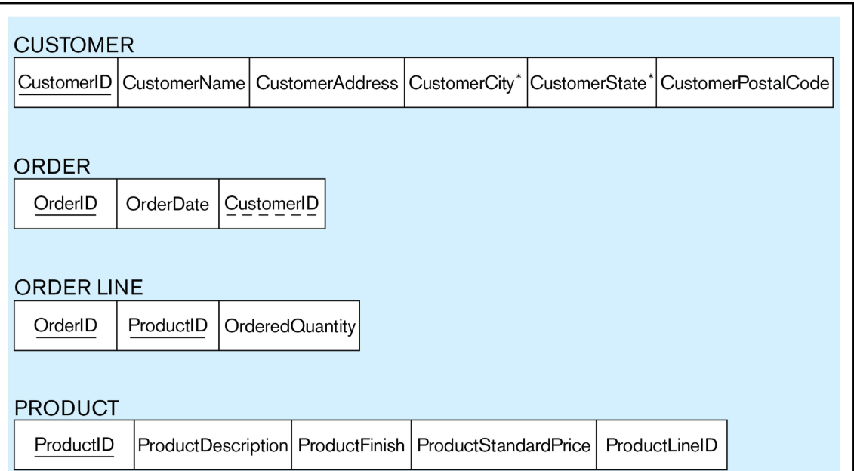
Figure 4-3 Schema for four relations (Pine Valley Furniture Company)

Following is a text description of these relations:

CUSTOMER(CustomerID, CustomerName, CustomerAddress,
CustomerCity, CustomerState, CustomerPostalCode)
ORDER(OrderID, OrderDate, CustomerID)
ORDER LINE(OrderID, ProductID, OrderedQuantity)
PRODUCT(ProductID, ProductDescription, ProductFinish,
ProductStandardPrice, ProductLineID)
Notice that the primary key for ORDER LINE is a composite key consisting of the attributes OrderID and ProductID. Also, CustomerID is a foreign key in the ORDER relation; this allows the user to associate an order with the customer who submitted the order. ORDER LINE has two foreign keys: OrderID and ProductID. These keys allow the user to associate each line on an order with the relevant order and product. In cases when a foreign key is also part of a composite key (such as this), frequently only the primary key role of the attribute is marked with a solid underline.

An instance of this database is shown in Figure 4-4. This figure shows four tables with sample data. Notice how the foreign keys allow us to associate the various tables. It is a good idea to create an instance of your relational schema with sample data for four reasons:

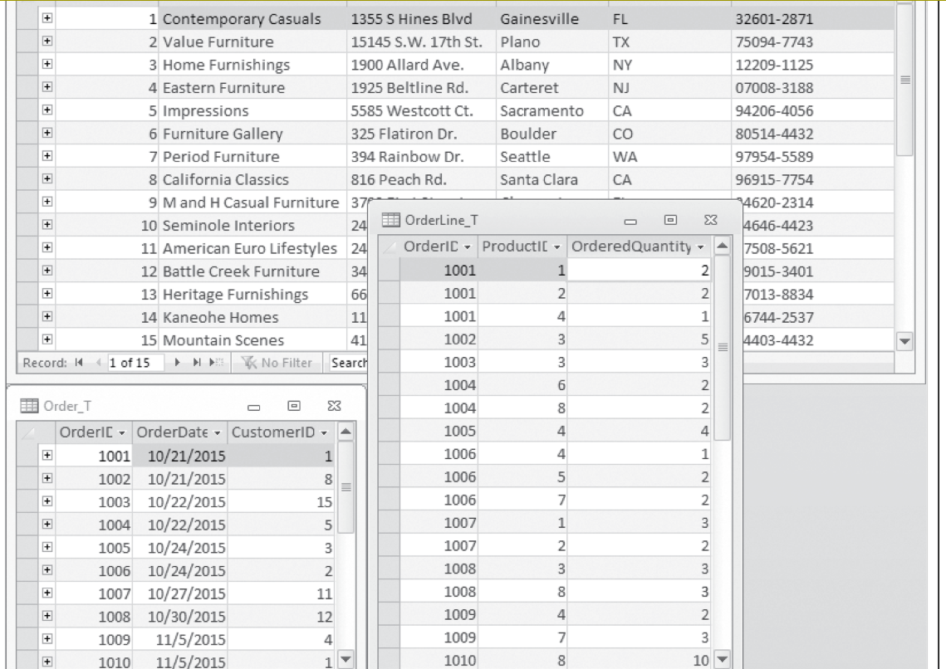
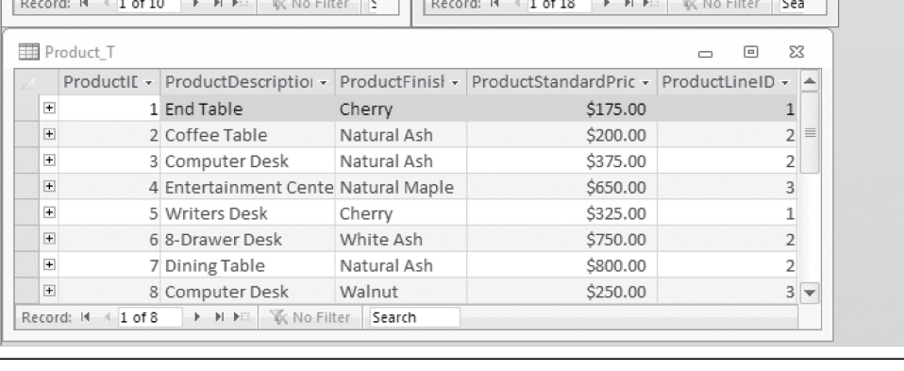
Figure 4-4 Instance of a relational schema (Pine Valley Furniture Company)
The sample data allow you to test your assumptions regarding the design.

The sample data provide a convenient way to check the accuracy of your design.

The sample data help improve communications with users in discussing your design.

The sample data can be used to develop prototype applications and to test queries.

Integrity Constraints
The relational data model includes several types of constraints, or rules limiting acceptable values and actions, whose purpose is to facilitate maintaining the accuracy and integrity of data in the database. The major types of integrity constraints are domain constraints, entity integrity, and referential integrity.

Domain Constraints
All of the values that appear in a column of a relation must be from the same domain. A domain is the set of values that may be assigned to an attribute. A domain definition usually consists of the following components: domain name, meaning, data type, size (or length), and allowable values or allowable range (if applicable). Table 4-1 (page 162) shows domain definitions for the domains associated with the attributes in Figures 4-3 and 4-4.

Entity Integrity
The entity integrity rule is designed to ensure that every relation has a primary key and that the data values for that primary key are all valid. In particular, it guarantees that every primary key attribute is non-null.

In some cases, a particular attribute cannot be assigned a data value. There are two situations in which this is likely to occur: Either there is no applicable data value or the applicable data value is not known when values are assigned. Suppose, for example, that you fill out an employment form that has a space reserved for a fax number. If you have no fax number, you leave this space empty because it does not apply to you. Or suppose that you are asked to fill in the telephone number of your previous employer. If you do not recall this number, you may leave it empty because that information is not known. You might also want to leave it empty because you do not want your current employer to know that you are seeking for another position.

The relational data model allows us to assign a null value to an attribute in the just described situations. A null is a value that may be assigned to an attribute when no other value applies or when the applicable value is unknown. In reality, a null is not a value, but rather it indicates the absence of a value. For example, it is not the same as a numeric zero or a string of blanks. The inclusion of nulls in the relational model is somewhat controversial, because it sometimes leads to anomalous results (Date, 2003). However, Codd, the inventor of the relational model, advocates the use of nulls for missing values (Codd, 1990).

Null
A value that may be assigned to an attribute when no other value applies or when the applicable value is unknown.

Table 4-1 Domain Definitions for INVOICE Attributes
Attribute Domain Name Description Domain
CustomerID Customer IDs Set of all possible customer IDs character: size 5
CustomerName Customer Names Set of all possible customer names character: size 25
CustomerAddress Customer Addresses Set of all possible customer addresses character: size 30
CustomerCity Cities Set of all possible cities character: size 20
CustomerState States Set of all possible states character: size 2
CustomerPostalCode Postal Codes Set of all possible postal zip codes character: size 10
OrderID Order IDs Set of all possible order IDs character: size 5
OrderDate Order Dates Set of all possible order dates date: format mm/dd/yy
ProductID Product IDs Set of all possible product IDs character: size 5
ProductDescription Product Descriptions Set of all possible product descriptions character: size 25
ProductFinish Product Finishes Set of all possible product finishes character: size 15
ProductStandardPrice Unit Prices Set of all possible unit prices monetary: 6 digits
ProductLineID Product Line IDs Set of all possible product line IDs integer: 3 digits
OrderedQuantity Quantities Set of all possible ordered quantities integer: 3 digits
Everyone agrees that primary key values must not be allowed to be null. Thus, the entity integrity rule states the following: No primary key attribute (or component of a primary key attribute) may be null.

Entity integrity rule
A rule that states that no primary key attribute (or component of a primary key attribute) may be null.

Referential Integrity
In the relational data model, associations between tables are defined through the use of foreign keys. For example, in Figure 4-4, the association between the CUSTOMER and ORDER tables is defined by including the CustomerID attribute as a foreign key in ORDER. This implies that before we insert a new row in the ORDER table, the customer for that order must already exist in the CUSTOMER table. If you examine the rows in the ORDER table in Figure 4-4, you will find that every customer number for an order already appears in the CUSTOMER table.

A referential integrity constraint is a rule that maintains consistency among the rows of two relations. The rule states that if there is a foreign key in one relation, either each foreign key value must match a primary key value in another relation or the foreign key value must be null. You should examine the tables in Figure 4-4 to check whether the referential integrity rule has been enforced.

Referential integrity constraint
A rule that states that either each foreign key value must match a primary key value in another relation or the foreign key value must be null.

The graphical version of the relational schema provides a simple technique for ­identifying associations where referential integrity must be enforced. Figure 4-5 shows the schema for the relations introduced in Figure 4-3. An arrow has been drawn from each ­foreign key to the associated primary key. A referential integrity constraint must be defined for each of these arrows in the schema. Please remember that OrderID and ProductID in ORDER LINE are both foreign keys and components of a composite ­primary key.

How do you know whether a foreign key is allowed to be null? If each order must have a customer (a mandatory relationship), then the foreign key CustomerID cannot be null in the ORDER relation. If the relationship is optional, then the foreign key could be null. Whether a foreign key can be null must be specified as a property of the foreign key attribute when the database is defined.

Actually, whether a foreign key can be null is more complex to model on an E-R diagram and to determine than we have shown so far. For example, what happens to order data if we choose to delete a customer who has submitted orders? We may want to see sales even if we do not care about the customer any more. Three choices are possible:

Delete the associated orders (called a cascading delete), in which case we lose not only the customer but also all the sales history.

Prohibit deletion of the customer until all associated orders are first deleted (a safety check).

Place a null value in the foreign key (an exception stating that although an order must have a CustomerID value when the order is created, CustomerID can become null later if the associated customer is deleted).
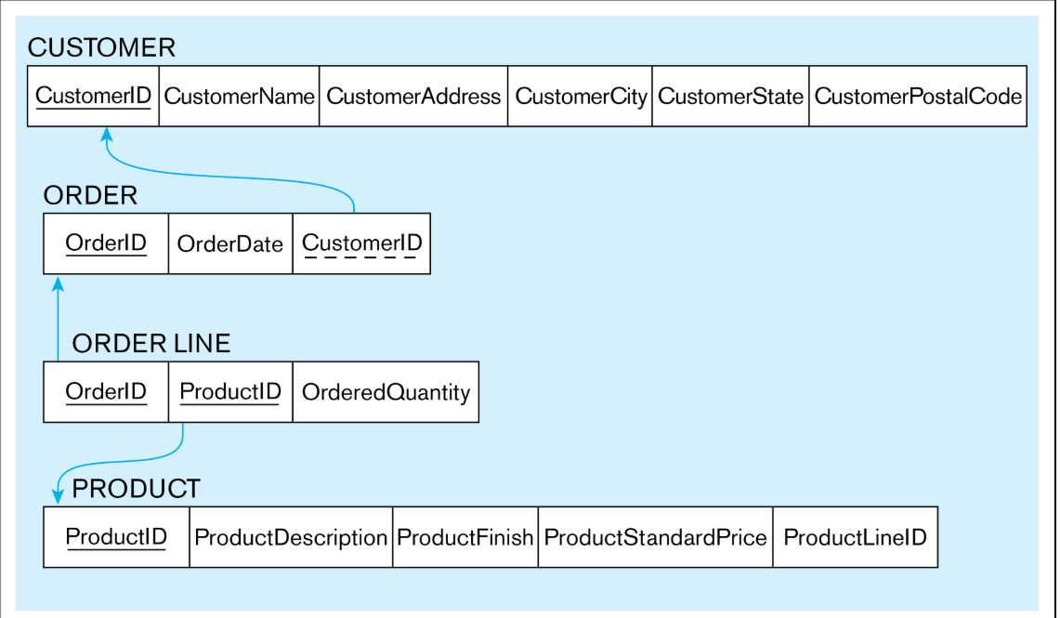

Figure 4-5 Referential integrity constraints (Pine Valley Furniture Company)
We will see how each of these choices is implemented when we describe the SQL database query language in Chapter 6. Please note that in practice, organizational rules and various regulations regarding data retention often determine what data can be deleted and when, and they therefore govern the choice between various deletion options.

Creating Relational Tables
In this section, we create table definitions for the four tables shown in Figure 4-5. These definitions are created using the CREATE TABLE statements of the SQL data definition language. In practice, these table definitions are actually created during the ­implementation phase later in the database development process. However, we show these ­sample tables in this chapter for continuity and especially to illustrate the way the integrity constraints described previously are implemented in SQL.

The SQL table definitions are shown in Figure 4-6. One table is created for each of the four relations shown in the relational schema (Figure 4-5). Each attribute for a table is then defined. Notice that the data type and length for each attribute are taken from the domain definitions (Table 4-1). For example, the attribute CustomerName in the Customer_T table is defined as VARCHAR (variable character) data type with length 25. By specifying NOT NULL, each attribute can be constrained from being assigned a null value.
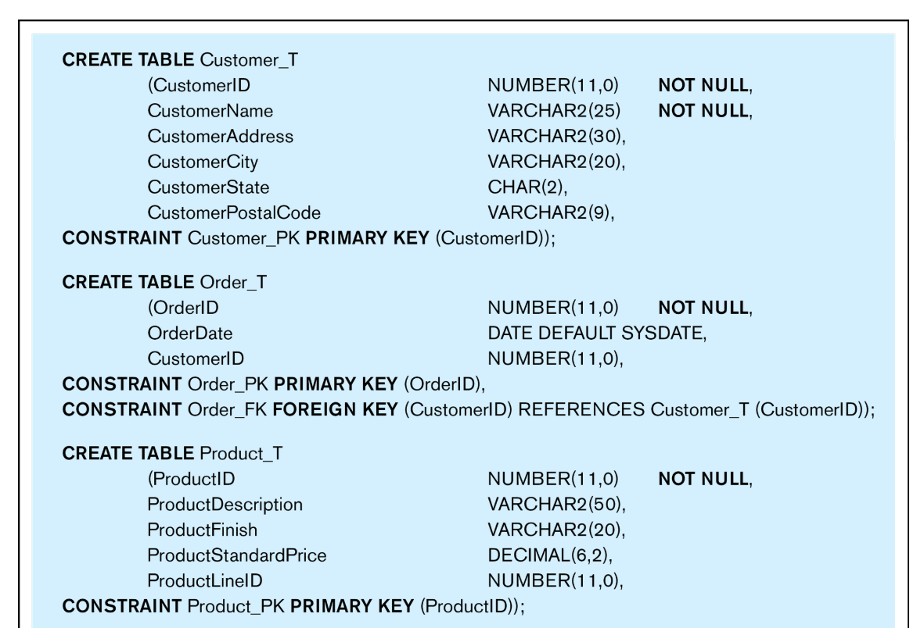
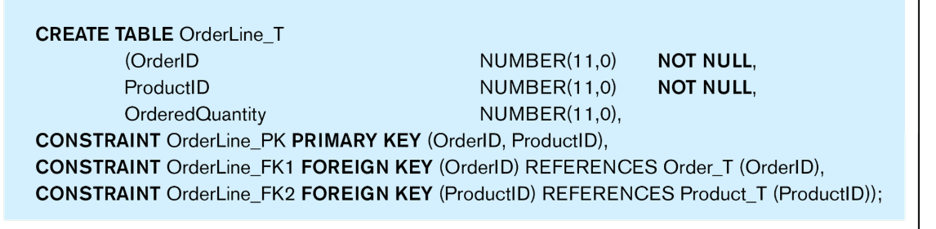
Figure 4-6 SQL table definitions
The primary key is specified for each table using the PRIMARY KEY clause at the end of each table definition. The OrderLine_T table illustrates how to specify a primary key when that key is a composite attribute. In this example, the primary key of OrderLine_T is the combination of OrderID and ProductID. Each primary key attribute in the four tables is constrained with NOT NULL. This enforces the entity integrity constraint described in the previous section. Notice that the NOT NULL constraint can also be used with non-primary-key attributes.

Referential integrity constraints are easily defined, based on the graphical schema shown in Figure 4-5. An arrow originates from each foreign key and points to the related primary key in the associated relation. In the SQL table definition, a FOREIGN KEY REFERENCES statement corresponds to each of these arrows. Thus, for the table Order_T, the foreign key CustomerID references the primary key of Customer_T, which is also called CustomerID. Although in this case the foreign key and primary key have the same name, this is not required. For example, the foreign key attribute could be named CustNo instead of CustomerID. However, the foreign and primary keys must be from the same domain (i.e., they must have the same data type).

The OrderLine_T table provides an example of a table that has two foreign keys. Foreign keys in this table reference the Order_T and Product_T tables, respectively. Please note that these two foreign keys are also the components of the primary key of OrderLine_T. This type of structure is very common as an implementation of a ­many-to-many relationship.

Well-Structured Relations
To prepare for our discussion of normalization, we need to address the following question: What constitutes a well-structured relation? Intuitively, a well-structured relation contains minimal redundancy and allows users to insert, modify, and delete the rows in a table without errors or inconsistencies. EMPLOYEE1 (Figure 4-1) is such a relation. Each row of the table contains data describing one employee, and any modification to an employee’s data (such as a change in salary) is confined to one row of the table. In contrast, EMPLOYEE2 (Figure 4-2b) is not a well-structured relation. If you examine the sample data in the table, you will notice considerable redundancy. For example, values for EmpID, Name, DeptName, and Salary appear in two separate rows for employees 100, 110, and 150. Consequently, if the salary for employee 100 changes, we must record this fact in two rows.

Well-structured relation
A relation that contains minimal redundancy and allows users to insert, modify, and delete the rows in a table without errors or inconsistencies.

Redundancies in a table may result in errors or inconsistencies (called anomalies ) when a user attempts to update the data in the table. We are typically concerned about three types of anomalies:

Anomaly
An error or inconsistency that may result when a user attempts to update a table that contains redundant data. The three types of anomalies are insertion, deletion, and modification anomalies.

Insertion anomaly Suppose that we need to add a new employee to EMPLOYEE2. The primary key for this relation is the combination of EmpID and CourseTitle (as noted earlier). Therefore, to insert a new row, the user must supply values for both EmpID and CourseTitle (because primary key values cannot be null or nonexistent). This is an anomaly because the user should be able to enter employee data without supplying course data.

Deletion anomaly Suppose that the data for employee number 140 are deleted from the table. This will result in losing the information that this employee completed a course (Tax Acc) on 12/8/2015. In fact, it results in losing the information that this course had an offering that completed on that date.

Modification anomaly Suppose that employee number 100 gets a salary increase. We must record the increase in each of the rows for that employee (two occurrences in Figure 4-2); otherwise, the data will be inconsistent.

These anomalies indicate that EMPLOYEE2 is not a well-structured relation. The problem with this relation is that it contains data about two entities: EMPLOYEE and COURSE. We will use normalization theory (described later in this chapter) to divide EMPLOYEE2 into two relations. One of the resulting relations is EMPLOYEE1 (Figure 4-1). The other we will call EMP COURSE, which appears with sample data in Figure 4-7. The primary key of this relation is the combination of EmpID and CourseTitle, and we underline these attribute names in Figure 4-7 to highlight this fact. Examine Figure 4-7 to verify that EMP COURSE is free of the types of anomalies described ­previously and is therefore well structured.


Figure 4-7 EMP COURSE

ransforming EER Diagrams into Relations
During logical design, you transform the E-R (and EER) diagrams that were developed during conceptual design into relational database schemas. The inputs to this process are the entity-relationship (and enhanced E-R) diagrams that you studied in Chapters 2 and 3. The outputs are the relational schemas described in the first two sections of this chapter.
Transforming (or mapping) EER diagrams into relations is a relatively straightforward process with a well-defined set of rules. In fact, many CASE tools can automatically perform many of the conversion steps. However, it is important that you understand the steps in this process for four reasons:
- CASE tools often cannot model more complex data relationships such as ternary relationships and supertype/subtype relationships. In these situations, you may have to perform the steps manually.
- There are sometimes legitimate alternatives for which you will need to choose a particular solution.
- You must be prepared to perform a quality check on the results obtained with a CASE tool.
- Understanding the transformation process helps you understand why conceptual data modeling (modeling the real-world domain) is different from logical data modeling (i.e., representing the data items within the domain in a way that can be implemented with a DBMS).
In the following discussion, we illustrate the steps in the transformation with examples taken from Chapters 2 and 3. It will help for you to recall that we discussed three types of entities in those chapters:
- Regular entities are entities that have an independent existence and generally represent real-world objects, such as persons and products. Regular entity types are represented by rectangles with a single line.
- Weak entities are entities that cannot exist except with an identifying relationship with an owner (regular) entity type. Weak entities are identified by a rectangle with a double line.
- Associative entities (also called gerunds) are formed from many-to-many relationships between other entity types. Associative entities are represented by a rectangle with rounded corners.

Step 1: Map Regular Entities
Each regular entity type in an E-R diagram is transformed into a relation. The name given to the relation is generally the same as the entity type. Each simple attribute of the entity type becomes an attribute of the relation. The identifier of the entity type becomes the primary key of the corresponding relation. You should check to make sure that this primary key satisfies the desirable properties of identifiers outlined in Chapter 2.
Figure 4-8a shows a representation of the CUSTOMER entity type for Pine Valley Furniture Company from Chapter 2 (see Figure 2-22). The corresponding CUSTOMER relation is shown in graphical form in Figure 4-8b. In this figure and those that follow in this section, we show only a few key attributes for each relation to simplify the figures.
(a) CUSTOMER entity type
(b) CUSTOMER relation

Figure 4-8 Example of mapping a regular entity

Composite Attributes
When a regular entity type has a composite attribute, only the simple components of the composite attribute are included in the new relation as its attributes. Figure 4-9 shows a variant of the example in Figure 4-8, where Customer Address is represented as a composite attribute with components Street, City, and State (see Figure 4-9a). This entity is mapped to the CUSTOMER relation, which contains the simple address attributes, as shown in Figure 4-9b. Although Customer Name is modeled as a simple attribute in Figure 4-9a, it could have been (and, in practice, would have been) modeled as a composite attribute with components Last Name, First Name, and Middle Initial. In designing the CUSTOMER relation (Figure 4-9b), you may choose to use these simple attributes instead of CustomerName. Compared to composite attributes, simple attributes improve data accessibility and facilitate maintaining data quality. For example, for data reporting and other output purposes it is much easier if CustomerName is represented with its components (last name, first name, and middle initial separately). This way, any process reporting the data can easily create any format it needs to.
(a) CUSTOMER entity type with composite attribute

(b) CUSTOMER relation with address detail

Figure 4-9 Example of mapping a composite attribute

Multivalued Attributes
When the regular entity type contains a multivalued attribute, two new relations (rather than one) are created. The first relation contains all of the attributes of the entity type except the multivalued attribute. The second relation contains two attributes that form the primary key of the second relation. The first of these attributes is the primary key from the first relation, which becomes a foreign key in the second relation. The second is the multivalued attribute. The name of the second relation should capture the meaning of the multivalued attribute.
An example of this procedure is shown in Figure 4-10. This is the EMPLOYEE entity type for Pine Valley Furniture Company. As shown in Figure 4-10a, EMPLOYEE has Skill as a multivalued attribute. Figure 4-10b shows the two relations that are created. The first (called EMPLOYEE) has the primary key EmployeeID. The second relation (called EMPLOYEE SKILL) has the two attributes, EmployeeID and Skill, which form the primary key. The relationship between foreign and primary keys is indicated by the arrow in the figure.
(a) EMPLOYEE entity type with multivalued attribute

(b) EMPLOYEE and EMPLOYEE SKILL relations

Figure 4-10 Example of mapping an entity with a multivalued attribute
The relation EMPLOYEE SKILL contains no nonkey attributes (also called descriptors). Each row simply records the fact that a particular employee possesses a particular skill. This provides an opportunity for you to suggest to users that new attributes can be added to this relation. For example, the attributes YearsExperience and/or CertificationDate might be appropriate new values to add to this relation. (See Figure 2-15b for another variation on employee skills.) If SKILL itself needs additional attributes, you can create a separate SKILL relation. In this case, EMPLOYEE SKILL becomes an associative entity between EMPLOYEE and SKILL.
If an entity type contains multiple multivalued attributes, each of them will be converted to a separate relation.

Step 2: Map Weak Entities
Recall that a weak entity type does not have an independent existence but exists only through an identifying relationship with another entity type called the owner. A weak entity type does not have a complete identifier but must have an attribute called a partial identifier that permits distinguishing the various occurrences of the weak entity for each owner entity instance.
The following procedure assumes that you have already created a relation corresponding to the identifying entity type during Step 1. If you have not, you should create that relation now, using the process described in Step 1.
For each weak entity type, create a new relation and include all of the simple attributes (or simple components of composite attributes) as attributes of this relation. Then include the primary key of the identifying relation as a foreign key attribute in this new relation. The primary key of the new relation is the combination of this primary key of the identifying relation and the partial identifier of the weak entity type.
An example of this process is shown in Figure 4-11. Figure 4-11a shows the weak entity type DEPENDENT and its identifying entity type EMPLOYEE, linked by the identifying relationship Claims (see Figure 2-5). Notice that the attribute Dependent Name, which is the partial identifier for this relation, is a composite attribute with components First Name, Middle Initial, and Last Name. Thus, we assume that, for a given employee, these items will uniquely identify a dependent (a notable exception being the case of prizefighter George Foreman, who has named all his sons after himself).
(a) Weak entity DEPENDENT

(b) Relations resulting from weak entity

Figure 4-11 Example of mapping a weak entity
Figure 4-11b shows the two relations that result from mapping this E-R segment. The primary key of DEPENDENT consists of four attributes: EmployeeID, FirstName, MiddleInitial, and LastName. DateOfBirth and Gender are the nonkey attributes. The foreign key relationship with its primary key is indicated by the arrow in the figure.
In practice, an alternative approach is often used to simplify the primary key of the DEPENDENT relation: Create a new attribute (called DependentID), which will be used as a surrogate primary key in Figure 4-11b. With this approach, the relation DEPENDENT has the following attributes:
Surrogate primary key
A serial number or other system-assigned primary key for a relation.
DEPENDENT(DependentID, EmployeeID, FirstName, MiddleInitial,
LastName, DateOfBirth, Gender)
DependentID is simply a serial number that is assigned to each dependent of an employee. Notice that this solution will ensure unique identification for each dependent (even for those of George Foreman!).

When to Create a Surrogate Key
A surrogate key is usually created to simplify the key structures. According to Hoberman (2006), a surrogate key should be created when any of the following conditions hold:
- There is a composite primary key, as in the case of the DEPENDENT relation shown previously with the four-component primary key.
- The natural primary key (i.e., the key used in the organization and recognized in conceptual data modeling as the identifier) is inefficient. For example, it may be very long and hence costly for database software to handle if it is used as a foreign key that references other tables.
- The natural primary key is recycled (i.e., the key is reused or repeated periodically, so it may not actually be unique over time); a more general statement of this condition is when the natural primary key cannot, in fact, be guaranteed to be unique over time (e.g., there could be duplicates, such as with names or titles).
Whenever a surrogate key is created, the natural key is always kept as nonkey data in the same relation because the natural key has organizational meaning that has to be captured in the database. In fact, surrogate keys mean nothing to users, so they are usually never shown to the user. Instead, the natural keys are used as identifiers in searches.

Step 3: Map Binary Relationships
The procedure for representing relationships depends on both the degree of the relationships (unary, binary, or ternary) and the cardinalities of the relationships. We describe and illustrate the important cases in the following discussion.

Map Binary One-to-Many Relationships
For each binary 1:M relationship, first create a relation for each of the two entity types participating in the relationship, using the procedure described in Step 1. Next, include the primary key attribute (or attributes) of the entity on the one-side of the relationship as a foreign key in the relation that is on the many-side of the relationship. (A mnemonic you can use to remember this rule is this: The primary key migrates to the many side.)

To illustrate this simple process, we use the Submits relationship between customers and orders for Pine Valley Furniture Company (see Figure 2-22). This 1:M relationship is illustrated in Figure 4-12a. (Again, we show only a few attributes for simplicity.) Figure 4-12b shows the result of applying this rule to map the entity types with the 1:M relationship. The primary key CustomerID of CUSTOMER (the one side) is included as a foreign key in ORDER (the many side). The foreign key relationship is indicated with an arrow. Please note that it is not necessary to name the foreign key attribute CustomerID. It is, however, essential that it has the same domain as the primary key it references.
(a) Relationship between CUSTOMER and ORDER entities

(b) CUSTOMER and ORDER relations with a foreign key in ORDER

Figure 4-12 Example of mapping a 1:M relationship

Map Binary Many-to-Many Relationships
Suppose that there is a binary many-to-many (M:N) relationship between two entity types, A and B. For such a relationship, create a new relation, C. Include as foreign key attributes in C the primary key for each of the two participating entity types. These attributes together become the primary key of C. Any nonkey attributes that are associated with the M:N relationship are included with the relation C.
Figure 4-13 shows an example of applying this rule. Figure 4-13a shows the Completes relationship between the entity types EMPLOYEE and COURSE from Figure 2-11a. Figure 4-13b shows the three relations (EMPLOYEE, COURSE, and CERTIFICATE) that are formed from the entity types and the Completes relationship. If Completes had been represented as an associative entity, as is done in Figure 2-11b, a similar result would occur, but we will deal with associative entities in a subsequent section. In the case of an M:N relationship, a relation is first created for each of the two regular entity types EMPLOYEE and COURSE. Then a new relation (named CERTIFICATE in Figure 4-13b) is created for the Completes relationship. The primary key of CERTIFICATE is the combination of EmployeeID and CourseID, which are the respective primary keys of EMPLOYEE and COURSE. As indicated in the diagram, these attributes are foreign keys that “point to” the respective primary keys. The nonkey attribute DateCompleted also appears in CERTIFICATE. Although not shown here, it is often wise to create a surrogate primary key for the CERTIFICATE relation.
(a) Completes relationship (M:N)

(b) Three resulting relations

Figure 4-13 Example of mapping a M:N relationship

Map Binary One-to-One Relationships
Binary one-to-one relationships can be viewed as a special case of one-to-many relationships. The process of mapping such a relationship to relations requires two steps. First, two relations are created, one for each of the participating entity types. Second, the primary key of one of the relations is included as a foreign key in the other relation.
In a 1:1 relationship, the association in one direction is nearly always an optional one, whereas the association in the other direction is a mandatory one. (You can review the notation for these terms in Figure 2-1.) You should include in the relation on the optional side of the relationship a foreign key referencing the primary key of the entity type that has the mandatory participation in the 1:1 relationship. This approach will prevent the need to store null values in the foreign key attribute. Any attributes associated with the relationship itself are also included in the same relation as the foreign key.
An example of applying this procedure is shown in Figure 4-14. Figure 4-14a shows a binary 1:1 relationship between the entity types NURSE and CARE CENTER. Each care center must have a nurse who is in charge of that center. Thus, the association from CARE CENTER to NURSE is a mandatory one, whereas the association from NURSE to CARE CENTER is an optional one (since any nurse may or may not be in charge of a care center). The attribute Date Assigned is attached to the In Charge relationship.
(a) In Charge relationship (binary 1:1)

(b) Resulting relations

Figure 4-14 Example of mapping a binary 1:1 relationship
The result of mapping this relationship to a set of relations is shown in Figure 4-14b. The two relations NURSE and CARE CENTER are created from the two entity types. Because CARE CENTER is the optional participant, the foreign key is placed in this relation. In this case, the foreign key is NurseInCharge. It has the same domain as NurseID, and the relationship with the primary key is shown in the figure. The attribute DateAssigned is also located in CARE CENTER and would not be allowed to be null.

Step 4: Map Associative Entities
As explained in Chapter 2, when a data modeler encounters a many-to-many relationship, he or she may choose to model that relationship as an associative entity in the E-R diagram. This approach is most appropriate when the end user can best visualize the relationship as an entity type rather than as an M:Nrelationship. Mapping the associative entity involves essentially the same steps as mapping an M:N relationship, as described in Step 3.
The first step is to create three relations: one for each of the two participating entity types and a third for the associative entity. We refer to the relation formed from the associative entity as the associative relation. The second step then depends on whether on the E-R diagram an identifier was assigned to the associative entity.

Identifier not Assigned
If an identifier was not assigned, the default primary key for the associative relation is a composite key that consists of the two primary key attributes from the other two relations. These attributes are then foreign keys that reference the other two relations.
An example of this case is shown in Figure 4-15. Figure 4-15a shows the associative entity ORDER LINE that links the ORDER and PRODUCT entity types at Pine Valley Furniture Company (see Figure 2-22). Figure 4-15b shows the three relations that result from this mapping. Note the similarity of this example to that of an M:N relationship shown in Figure 4-13.
(a) An associative entity

(b) Three resulting relations

Figure 4-15 Example of mapping an associative entity

Identifier Assigned
Sometimes a data modeler will assign a single-attribute identifier to the associative entity type on the E-R diagram. Two reasons may have motivated the data modeler to assign a single-attribute key during conceptual data modeling:
- The associative entity type has a natural single-attribute identifier that is familiar to end users.
- The default identifier (consisting of the identifiers for each of the participating entity types) may not uniquely identify instances of the associative entity.
These motivations are in addition to the reasons mentioned earlier in this chapter to create a surrogate primary key.
The process for mapping the associative entity in this case is now modified as follows. As before, a new (associative) relation is created to represent the associative entity. However, the primary key for this relation is the identifier assigned on the E-R diagram (rather than the default key). The primary keys for the two participating entity types are then included as foreign keys in the associative relation.
An example of this process is shown in Figure 4-16. Figure 4-16a shows the associative entity type SHIPMENT that links the CUSTOMER and VENDOR entity types. Shipment ID has been chosen as the identifier for SHIPMENT for two reasons:
(a) SHIPMENT associative entity

(b) Three resulting relations

Figure 4-16 Example of mapping an associative entity with an identifier
- Shipment ID is a natural identifier for this entity that is very familiar to end users.
- The default identifier consisting of the combination of Customer ID and Vendor ID does not uniquely identify the instances of SHIPMENT. In fact, a given vendor typically makes many shipments to a given customer. Even including the attribute Date does not guarantee uniqueness, since there may be more than one shipment by a particular vendor on a given date. The surrogate key ShipmentID will, however, uniquely identify each shipment.
Two nonkey attributes associated with the SHIPMENT associative entity are Shipment Date and Shipment Amount.
The result of mapping this entity to a set of relations is shown in Figure 4-16b. The new associative relation is named SHIPMENT. The primary key is ShipmentID. CustomerID and VendorID are included as foreign keys in this relation, and ShipmentDate and ShipmentAmount are nonkey attributes. It is also possible that the designer decides as part of the logical modeling process to add a surrogate key into a relation that did not have it earlier. In these cases, it is highly recommended to update the conceptual model to keep it consistent.

Step 5: Map Unary Relationships
In Chapter 2, we defined a unary relationship as a relationship between the instances of a single entity type. Unary relationships are also called recursive relationships. The two most important cases of unary relationships are one-to-many and many-to-many relationships. We discuss these two cases separately because the approach to mapping is somewhat different for the two types.

Unary One-to-Many Relationships
The entity type in the unary relationship is mapped to a relation using the procedure described in Step 1. Next, a foreign key attribute is added to the same relation; this attribute references the primary key values in the same relation. (This foreign key must have the same domain as the primary key.) This type of a foreign key is called a recursive foreign key.
Recursive foreign key
A foreign key in a relation that references the primary key values of the same relation.
﻿﻿ ﻿
Figure 4-17a shows a unary one-to-many relationship named Manages that associates each employee of an organization with another employee who is his or her manager. Each employee may have one manager; a given employee may manage zero to many employees.
(a) EMPLOYEE entity with unary relationship

(b) EMPLOYEE relation with recursive foreign key

Figure 4-17 Example of mapping a unary 1:M relationship
The EMPLOYEE relation that results from mapping this entity and relationship is shown in Figure 4-17b. The (recursive) foreign key in the relation is named ManagerID. This attribute has the same domain as the primary key EmployeeID. Each row of this relation stores the following data for a given employee: EmployeeID, EmployeeName, EmployeeDateOfBirth, and ManagerID (i.e., EmployeeID for this employee’s manager). Notice that because it is a foreign key, ManagerID references EmployeeID.

Unary Many-to-Many Relationships
With this type of relationship, two relations are created: one to represent the entity type in the relationship and an associative relation to represent the M:Nrelationship itself. The primary key of the associative relation consists of two attributes. These attributes (which need not have the same name) both take their values from the primary key of the other relation. Any nonkey attribute of the relationship is included in the associative relation.
An example of mapping a unary M:N relationship is shown in Figure 4-18. Figure 4-18a shows a bill-of-materials relationship among items that are assembled from other items or components. (This structure was described in Chapter 2, and an example appears in Figure 2-13.) The relationship (called Contains) is M:N because a given item can contain numerous component items, and, conversely, an item can be used as a component in numerous other items.
(a) Bill-of-materials relationship Contains (M:N)

(b) ITEM and COMPONENT relations

Figure 4-18 Example of mapping a unary M:N relationship
The relations that result from mapping this entity and its relationship are shown in Figure 4-18b. The ITEM relation is mapped directly from the same entity type. COMPONENT is an associative relation whose primary key consists of two attributes that are arbitrarily named ItemNo and ComponentNo. The attribute Quantity is a nonkey attribute of this relation that, for a given item, records the quantity of a particular component item used in that item. Notice that both ItemNo and ComponentNo reference the primary key (ItemNo) of the ITEM relation. It is not unusual to give this relation a surrogate key to avoid any practical complexities related to the composite key.
We can easily query these relations to determine, for example, the components of a given item. The following SQL query will list the immediate components (and their quantity) for item number 100:
SELECT ComponentNo, Quantity
FROM Component_T
WHERE ItemNo = 100;

Step 6: Map Ternary (and n-ary) Relationships
Recall from Chapter 2 that a ternary relationship is a relationship among three entity types. In that chapter, we recommended that you convert a ternary relationship to an associative entity to represent participation constraints more accurately.
To map an associative entity type that links three regular entity types, we create a new associative relation. The default primary key of this relation consists of the three primary key attributes for the participating entity types. (In some cases, additional attributes are required to form a unique primary key.) These attributes then act in the role of foreign keys that reference the individual primary keys of the participating entity types. Any attributes of the associative entity type become attributes of the new relation.
An example of mapping a ternary relationship (represented as an associative entity type) is shown in Figure 4-19. Figure 4-19a is an E-R segment (or view) that represents a patient receiving a treatment from a physician. The associative entity type PATIENT TREATMENT has the attributes PTreatment Date, PTreatment Time, and PTreatment Results; values are recorded for these attributes for each instance of PATIENT TREATMENT.
(a) PATIENT TREATMENT ternary relationship with associative entity

(b) Four resulting relations

Figure 4-19 Example of mapping a ternary relationship
The result of mapping this view is shown in Figure 4-19b. The primary key attributes PatientID, PhysicianID, and TreatmentCode become foreign keys in PATIENT TREATMENT. The foreign key into TREATMENT is called PTreatmentCode in PATIENT TREATMENT. We are using this column name to illustrate that the foreign key name does not have to be the same as the name of the primary key to which it refers, as long as the values come from the same domain. These three attributes are components of the primary key of PATIENT TREATMENT. However, they do not uniquely identify a given treatment, because a patient may receive the same treatment from the same physician on more than one occasion. Does including the attribute Date as part of the primary key (along with the other three attributes) result in a primary key? This would be so if a given patient receives only one treatment from a particular physician on a given date. However, this is not likely to be the case. For example, a patient may receive a treatment in the morning, then the same treatment again in the afternoon. To resolve this issue, we include PTreatmentDate and PTreatmentTime as part of the primary key. Therefore, the primary key of PATIENT TREATMENT consists of the five attributes shown in Figure 4-19b: PatientID, PhysicianID, TreatmentCode, PTreatmentDate, and PTreatmentTime. The only nonkey attribute in the relation is PTreatmentResults.
Although this primary key is technically correct, it is complex and therefore difficult to manage and prone to errors. A better approach is to introduce a surrogate key, such as PTreatmentID, that is, a serial number that uniquely identifies each treatment. In this case, each of the former primary key attributes except for PTreatmentDate and PTreatmentTime becomes a foreign key in the PATIENT TREATMENT relation. Another similar approach is to use an enterprise key, as described at the end of this chapter.

Step 7: Map Supertype/Subtype Relationships
The relational data model does not yet directly support supertype/subtype relationships. Fortunately, there are various strategies that database designers can use to represent these relationships with the relational data model (Chouinard, 1989). For our purposes, we use the following strategy, which is the one most commonly employed:
- Create a separate relation for the supertype and for each of its subtypes.
- Assign to the relation created for the supertype the attributes that are common to all members of the supertype, including the primary key.
- Assign to the relation for each subtype the primary key of the supertype and only those attributes that are unique to that subtype.
- Assign one (or more) attributes of the supertype to function as the subtype discriminator. (The role of the subtype discriminator was discussed in Chapter3.)
An example of applying this procedure is shown in Figures 4-20 and 4-21. Figure 4-20 shows the supertype EMPLOYEE with subtypes HOURLY EMPLOYEE, SALARIED EMPLOYEE, and CONSULTANT. (This example is described in Chapter 3, and Figure 4-20 is a repeat of Figure 3-8.) The primary key of EMPLOYEE is Employee Number, and the attribute Employee Type is the subtype discriminator.

Figure 4-20 Supertype/subtype relationships

Figure 4-21 Mapping supertype/subtype relationships to relations
The result of mapping this diagram to relations using these rules is shown in Figure 4-21. There is one relation for the supertype (EMPLOYEE) and one for each of the three subtypes. The primary key for each of the four relations is EmployeeNumber. A prefix is used to distinguish the name of the primary key for each subtype. For example, SEmployeeNumber is the name for the primary key of the relation SALARIED EMPLOYEE. Each of these attributes is a foreign key that references the supertype primary key, as indicated by the arrows in the diagram. Each subtype relation contains only those attributes unique to the subtype.
For each subtype, a relation can be produced that contains all of the attributes of that subtype (both specific and inherited) by using an SQL command that joins the subtype with its supertype. For example, suppose that we want to display a table that contains all of the attributes for SALARIED EMPLOYEE. The following command is used:
SELECT *
FROM Employee_T, SalariedEmployee_T
WHERE EmployeeNumber = SEmployeeNumber;

Summary of EER-to-Relational Transformations
The steps provide a comprehensive explanation of how each element of an EER diagram is transformed into parts of a relational data model. Table 4-2 is a quick reference to these steps and the associated figures that illustrate each type of transformation.

Table 4-2 Summary of EER-to-Relational Transformations
EER Structure | Relational Representation (Sample Figure)
Regular entity | Create a relation with primary key and nonkey attributes (Figure 4-8)
Composite attribute | Each component of a composite attribute becomes a separate attribute in the target relation (Figure 4-9)
Multivalued attribute | Create a separate relation for multivalued attribute with composite primary key, including the primary key of the entity (Figure 4-10)
Weak entity | Create a relation with a composite primary key (which includes the primary key of the entity on which this entity depends) and nonkey attributes (Figure 4-11)
Binary or unary 1:Mrelationship | Place the primary key of the entity on the one side of the relationship as a foreign key in the relation for the entity on the many side (Figure 4-12; Figure 4-17 for unary relationship)
Binary or unary M:Nrelationship or associative entity without its own key | Create a relation with a composite primary key using the primary keys of the related entities plus any nonkey attributes of the relationship or associative entity (Figure 4-13, Figure 4-15 for associative entity, Figure 4-18 for unary relationship)
Binary or unary 1:1 relationship | Place the primary key of either entity in the relation for the other entity; if one side of the relationship is optional, place the foreign key of the entity on the mandatory side in the relation for the entity on the optional side (Figure 4-14)
Binary or unary M:Nrelationship or associative entity with its own key | Create a relation with the primary key associated with the associative entity plus any nonkey attributes of the associative entity and the primary keys of the related entities as foreign keys (Figure 4-16)
Ternary and n-ary relationships | Same as binary M:N relationships above; without its own key, include as part of primary key of relation for the relationship or associative entity the primary keys from all related entities; with its own surrogate key, the primary keys of the associated entities are included as foreign keys in the relation for the relationship or associative entity (Figure 4-19)
Supertype/subtype relationship | Create a relation for the superclass, which contains the primary and all nonkey attributes in common with all subclasses, plus create a separate relation for each subclass with the same primary key (with the same or local name) but with only the nonkey attributes related to that subclass (Figure 4-20 and 4-21)

Summary
Logical database design is the process of transforming the conceptual data model into a logical data model. The emphasis in this chapter has been on the relational data model, because of its importance in contemporary database systems. The relational data model represents data in the form of tables called relations. A relation is a named, two-dimensional table of data. A key property of relations is that they cannot contain multivalued attributes.
In this chapter, we described the major steps in the logical database design process. This process is based on transforming EER diagrams into normalized relations. This process has three steps: Transform EER diagrams into relations, normalize the relations, and merge the relations. The result of this process is a set of relations in third normal form that can be implemented using any contemporary relational database management system.
Each entity type in the EER diagram is transformed into a relation that has the same primary key as the entity type. A one-to-many relationship is represented by adding a foreign key to the relation that represents the entity on the many side of the relationship. (This foreign key is the primary key of the entity on the one side of the relationship.) A many-to-many relationship is represented by creating a separate relation. The primary key of this relation is a composite key, consisting of the primary key of each of the entities that participate in the relationship.
The relational model does not directly support supertype/subtype relationships, but we can model these relationships by creating a separate table (or relation) for the supertype and for each subtype. The primary key of each subtype is the same (or at least from the same domain) as for the supertype. The supertype must have an attribute called the subtype discriminator that indicates to which subtype (or subtypes) each instance of the supertype belongs.
The purpose of normalization is to derive well-structured relations that are free of anomalies (inconsistencies or errors) that would otherwise result when the relations are updated or modified. Normalization is based on the analysis of functional dependencies, which are constraints between two attributes (or two sets of attributes). It may be accomplished in several stages. Relations in first normal form (1NF) contain no multivalued attributes or repeating groups. Relations in second normal form (2NF) contain no partial dependencies, and relations in third normal form (3NF) contain no transitive dependencies. We can use diagrams that show the functional dependencies in a relation to help decompose that relation (if necessary) to obtain relations in 3NF. Higher normal forms (beyond 3NF) have also been defined; we discuss these normal forms in Appendix B, available on the book’s Web site.
We must be careful when combining relations to deal with problems such as synonyms, homonyms, transitive dependencies, and supertype/subtype relationships. In addition, before relations are defined to the database management system, all primary keys should be described as single-attribute nonintelligent keys and, preferably, as enterprise keys.

References
- Chouinard, P. 1989. “Supertypes, Subtypes, and DB2.” Database Programming & Design 2,10 (October): 50–57.
- Codd, E. F. 1970. “A Relational Model of Data for Large Shared Data Banks.” Communications of the ACM 13,6 (June): 77–87.
- Codd, E. F. 1990. The Relational Model for Database Management, Version 2. Reading, MA: Addison-Wesley.
- Date, C. J. 2003. An Introduction to Database Systems. 8th ed. Reading, MA: Addison-Wesley.
- Dutka, A. F., and H. H. Hanson. 1989. Fundamentals of Data Normalization. Reading, MA: Addison-Wesley.
- Fleming, C. C., and B. von Halle. 1989. Handbook of Relational Database Design. Reading, MA: Addison-Wesley.
- Hoberman, S. 2006. “To Surrogate Key or Not.” DM Review 16,8 (August): 29.
- Johnston, T. 2000. “Primary Key Reengineering Projects: The Problem” and “Primary Key Reengineering Projects: The Solution.” Available at www.information-management.com.
- Navathe, S., R. Elmasri, and J. Larson. 1986. “Integrating User Views in Database Design.” Computer 19,1 (January): 50–62.

Further Reading
- Elmasri, R., and S. Navathe. 2010. Fundamentals of Database Systems. 6th ed. Reading, MA: Addison Wesley.
- Hoffer, J. A., J. F. George, and J. S. Valacich. 2014. Modern Systems Analysis and Design. 7th ed. Upper Saddle River, NJ: Prentice Hall.
- Russell, T., and R. Armstrong. 2002. “13 Reasons Why Normalized Tables Help Your Business.” Database
- Administrator, April 20, 2002. Available at http://searchoracle.techtarget.com/tip/13-reasons-why-normalized-tables- help-your-business
- Storey, V. C. 1991. “Relational Database Design Based on the Entity-Relationship Model.” Data and Knowledge Engineering 7,1 (November): 47–83.

Web Resources
- http://en.wikipedia.org/wiki/Database_normalization Wikipedia entry that provides a thorough explanation of first, second, third, fourth, fifth, and Boyce-Codd normal forms.
- www.bkent.net/Doc/simple5.htm Web site that presents a summary paper by William Kent titled “A Simple Guide to Five Normal Forms in Relational Database Theory.”
- http://www.stevehoberman.com Web site where Steve Hoberman, a leading consultant and lecturer on database design, presents and analyzes database design (conceptual and logical) problem. These are practical (based on real experiences or questions sent to him) situations that make for interesting puzzles to solve.
- www.troubleshooters.com/codecorn/norm.htm Web page on normalization on Steve Litt’s site that contains various troubleshooting tips for avoiding programming and systems development problems.

